Q1

load cifar10_data_batch_1.mat

X = data(:,[1 4 5 8])

X = cast(X,'single')

[coeff,score,latent] = pca(X,'Centered',0)

PC1 = score(:,1)

PC2 = score(:,2)

scatter(PC1,PC2)

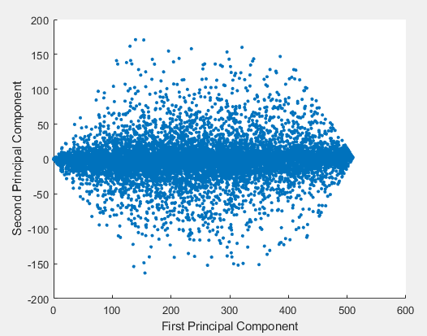

Q2

import data iris.txt in Numeric Matrix type

x = iris(:,1:2)

mean_overall = mean(x)

m1 = mean(x(1:50,:))

m2 = mean(x(51:100,:))

m3 = mean(x(101:150,:))

Sb = 50 * ((m1 - mean_overall)' * (m1 - mean_overall)) + 50 * ((m2 - mean_overall)' * (m2 - mean_overall)) + 50 * ((m3 - mean_overall)' * (m3 - mean_overall))

Sb =

63.2121 -19.5340

-19.5340 10.9776

S1 = cov(x(1:50,:))

S2 = cov(x(51:100,:))

S3 = cov(x(101:150,:))

Sw = S1 + S2 + S3

[V,D] = eig(inv(Sw) * Sb)

W = V(:,1)

Sb_after = W' * Sb * W

Sb_after =

49.6847

Q3

Gradient descent

Q4

Filter methods measure the relevance of features by their correlation with dependent variable while wrapper methods measure the usefulness of a subset of feature by actually training a model on it.

Filter methods are faster compared to wrapper methods.

Filter methods use statistical methods for evaluation while wrapper methods use cross validation.

Q5

The scatter plots show that the classes are well-separated when both features exist.

The covariance didn’t capture the means of class conditional distributions.